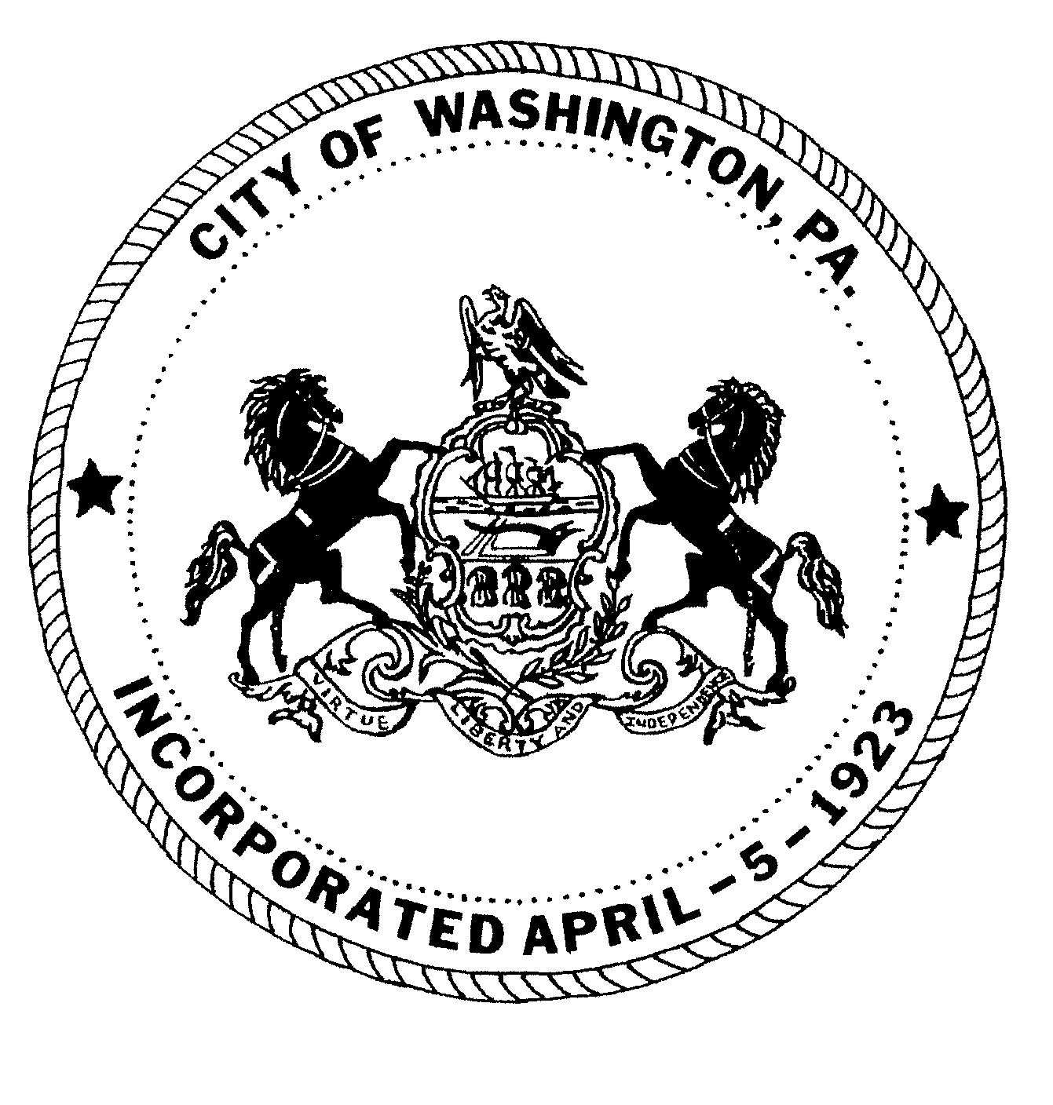
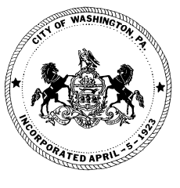
City of Washington
SPECIAL HEARING MINUTES
Washington CITY COUNCIL

October 30, 2023 5:15 P.M.
Scott J. Putnam, Mayor
City Council
Ken Westcott, Councilman
Joe Pintola, Councilman
Andrew Callan, Councilman
Joseph DeThomas, Councilman

ROLL CALL:
Councilman Joseph DeThomas - PRESENT
Councilman Andrew Callan - PRESENT
Councilman Joe Pintola - PRESENT
Councilman Ken Westcott - PRESENT
Mayor Scott Putnam - PRESENT

SOLICITOR:
Jack Cambest, Esquire-

A Public Hearing was held to receive testimony on the proposed transfer of Liquor License C-2488 (LID 1290) from Cecil Township into the City of Washington. The applicant is Washington Community Club, Inc. The location of the proposed transfer is 127 North Main Street, Washington, Pennsylvania, 15301.

A Court Reporter was present to type an official transcript.

Solicitor Jack Cambest presented EXHIBIT #1 Notification of Publication as required.

Michael J. Hudock III, council for the Washington Community Club, provided background information advising that the club was formed on September 20, 2022, by local residents. The club has participated in numerous charitable efforts over the past year. They are applying to the Liquor Control Board to transfer License C-2488 from Cecil Township to 127 North Main Street, Washington, PA 15301.

Attorney Cambest asked Mr. Hudock what type of liquor license they are applying for. Mr. Hudock stated that they are applying for a Club License, where they plan to sell beer, wine, and mixed beverages.

Mayor Putnam asked what hours they plan to operate. Mr. Hudock stated that although the license would permit for them to be open later, the club plans to operate Monday-

Saturday from 4:00 p.m. until 12:00 A.M. and on Sunday from 12:00 P.M. until 12:00 A.M.

Mayor Putnam also asked if the Club has a disciplinary board for members. Mr. Hudock stated that they do have a disciplinary board, which has the ability to hold disciplinary hearings if required and has the authority to recommend temporary or permanent suspension of members. The Club currently has 58 members, 17 of which are active members with voting privileges. The active members would vote on suspensions based on the recommendation of the disciplinary board.

Councilman DeThomas asked about parking accommodations for members. Member, Rashad Davison, stated that the Club has 30 private parking spaces and that there is also on-street parking. Councilman DeThomas asked what they planned to do if they have an increase in membership. Mr. Davison stated that there were other parking lots in the area that they will look into. He also mentioned that they are currently doing renovations on the 2nd floor. Donn Henderson, City Administrator, stated that they will need an occupancy and building permit.

Attorney Cambest advised Washington Community Club that City Council will vote this Thursday, November 2, 2023, on the Resolution to recommend approval of the liquor license transfer to the Liquor Control Board.

Motion made by Councilman Westcott, seconded by Councilman Callan, and unanimously carried to adjourn the meeting.

