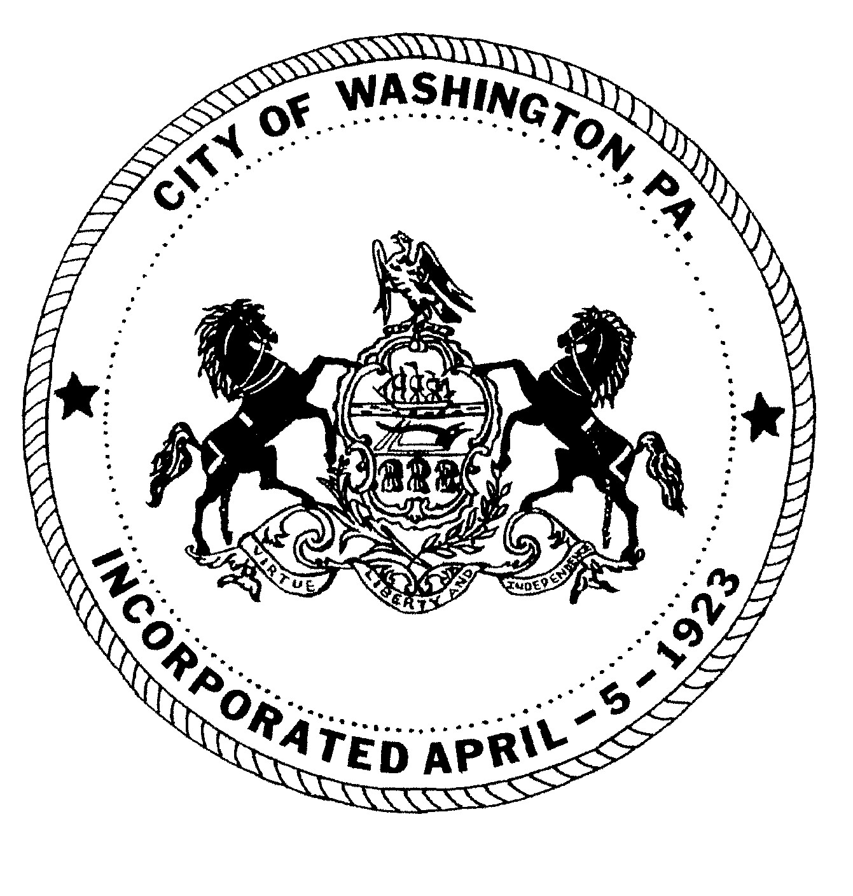
City of Washington
SPECIAL MEETING MEETING
Washington CITY COUNCIL

October 24, 2023 5:15 P.M.
Scott J. Putnam, Mayor
City Council
Ken Westcott, Councilman
Joe Pintola, Councilman
Andrew Callan, Councilman
Joseph DeThomas, Councilman

ROLL CALL:
Councilman Joseph DeThomas
Councilman Andrew Callan
Councilman Joe Pintola
Councilman Ken Westcott
Mayor Scott Putnam

SOLICITOR:
Jack Cambest, Esquire

MOMENT OF SILENCE

PLEDGE OF ALLEGIANCE TO THE FLAG

PUBLIC PARTICIPATION: Individuals or group representatives who have signed in prior to the meeting, will have 5 minutes of microphone time to address Council during the public participation portion of the meeting. We prefer if there is a group, a representative be chosen to speak. Audience comments will not be permitted following the public participation portion of the meeting; therefore, we ask that you please review the agenda for any item(s) you may wish to discuss. We have, in the past, had individuals’ direct comments to Mayor and Council that were not correct or could not be documented. For that reason, we ask that your information be to the point and factual. Although we may not be able to answer your question at this meeting, we will refer your request or recommendation to the proper department for any necessary action.

PUBLIC COMMENT:

CLOSED TO PUBLIC PARTICIPATION

- Motion to approve the following payments (a. – m.) in the amount of $272,655.42.
- Motion to approve the following transfer (a.) in the amount of $15,000.00.
- Motion to approve the resignation of Corey Anderson Public Works Employee effective October 27, 2023, pay all monies due and amend the Salary Resolution.
- Motion to approve employment for Nicholas Bryant as a Public Works Department Laborer, effective October 30, 2023, pending pre-employment screening.
- Motion to approve submitting a letter of support on behalf of the Washington Business District’s 2024 LSA Grant Application.
- Motion to approve submitting a letter of support on behalf of the Washington Historical Society’s (The Bradford House) 2024 LSA Grant Application.
- Motion to approve submitting a letter of support on behalf of the Citizen’s Library 2024 LSA Application.
- Motion to approve submitting a letter of support on behalf of the Washington Senior Citizens Center’s 2024 LSA Grant Application.
- Motion to approve the City’s application for the 2024 LSA Grant Application for Downtown Revitalization Phase II, including $20,000 in matching funds.
- Motion to approve the City’s application for a Redevelopment Assistance Capital Program (RACP) grant.
- Motion to approve the sales agreement to purchase Parcel 750-008-00-02-0003-00 68 & 68 ½ West Prospect Avenue for $80,000.00.
- Motion to approve the proposed façade improvements to the Senior Center Building upon receipt of façade grant.
- Motion to approve proposal from A & H equipment for spreader, plow and tarp cover
installation for the new Chevy Silverado 5500 in the amount of $19,824.00 and pay upon
completion from fund Capital Improvement Fund. CHARGE: 77.430-700.
- Motion to approve Fire Department usage and future development of a municipal training ground on the vacant site of Ramage Field.
- Motion to approve a City application for 2024 LSA Grant Funding to begin development of a municipal training ground.

RESOLUTIONS

- Motion to approve RESOLUTION 25 of 2023 approving authority for the City
Administrator to submit the Traffic Signal Maintenance Agreement, to submit future modifications to the Traffic Signal Maintenance Agreement, and to submit future Applications for Traffic Signal Approval either in writing or via electronic signature, to the Department of Transportation and to sign the agreement on behalf of the City of Washington.

- Motion to approve RESOLUTION 26 of 2023 to request a Statewide Local Share Assessment grant of $250,000.00 form the Commonwealth Financing Authority to be used for construction of Washington City Mission’s 50 Bed Shelter for Homeless Women at 84 West Wheeling Street, Washington PA 15301.

- The next scheduled Regular Council Meeting will be held on Thursday, November 2, 2023 at 6:00 P.M. in Council Chambers.
- A Demolition Hearing will be held at 5:00 P.M. prior to the Regular Agenda Meeting.
- The Agenda meeting will be held on Monday, October 30, 2023 at 6:00 P.M.
- A Special Hearing regarding a liquor license transfer will be held Monday, October 30, 2023 at 5:00 P.M. prior to the Agenda Meeting.

Motion to adjourn the meeting.

