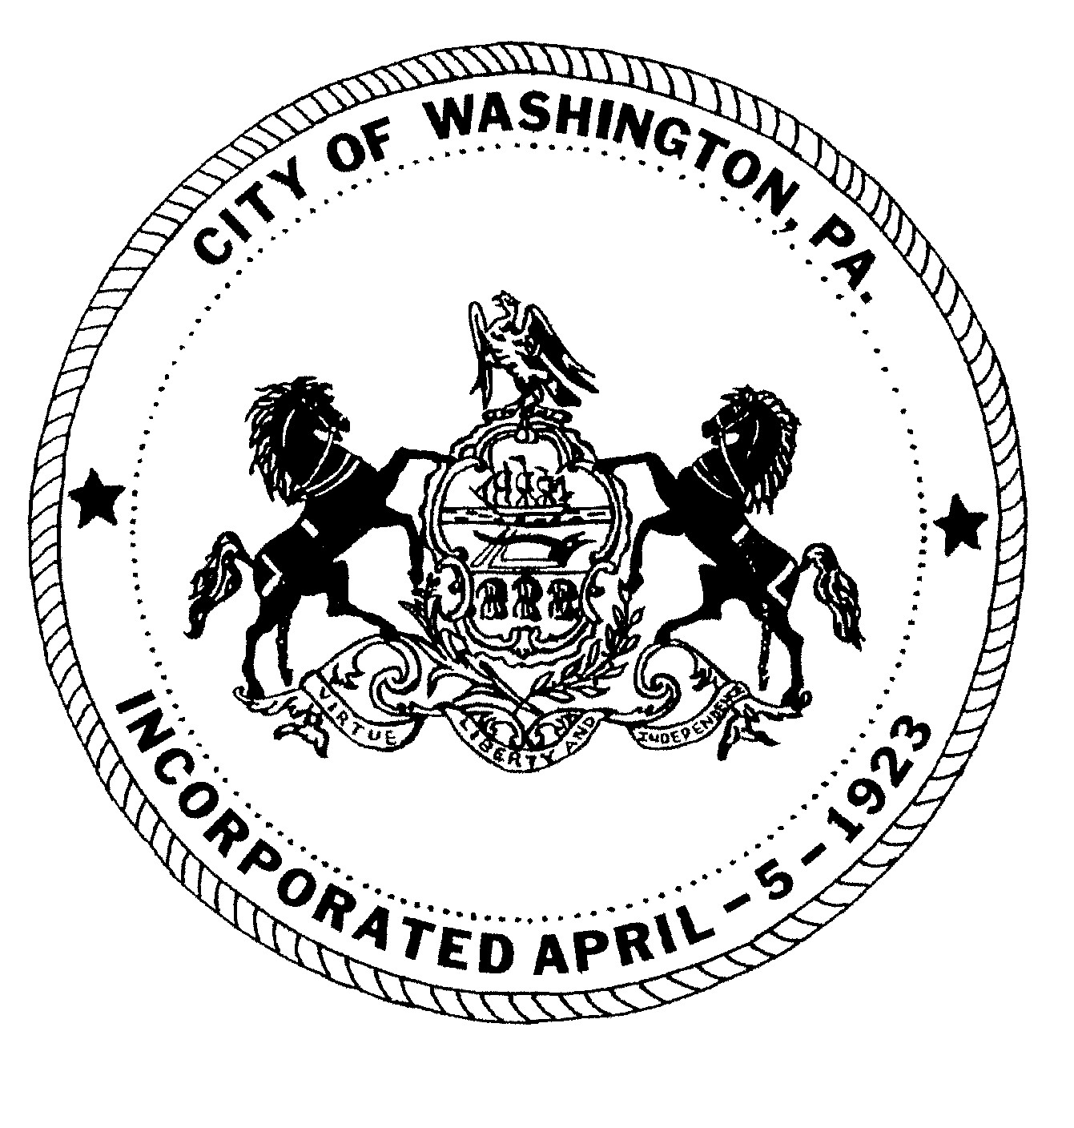
City of Washington
REGULAR MEETING MINUTES
Washington City Council

DECEMBER 5, 2024 6:00 P.M.
JoJo Burgess, Mayor
City Council
Ken Westcott, Councilman
Joe Pintola, Councilman
Andrew Callan, Councilman
Joseph DeThomas, Councilman

ROLL CALL:
Councilman Joseph DeThomas Present
Councilman Andrew Callan Present
Councilman Joe Pintola Present
Councilman Ken Westcott Present
Mayor JoJo Burgess Present

Solicitor: Jack Cambest Present

MOMENT OF SILENCE:

PLEDGE OF ALLEGIANCE:

PUBLIC PARTICIPATION: Individuals or group representatives who have signed in prior to the meeting will have 5 minutes of microphone time to address Council during the public participation portion of the meeting. We prefer if there is a group, a representative be chosen to speak. Audience comments will not be permitted following the public participation portion of the meeting; therefore, we ask that you please review the agenda for any item(s) you may wish to discuss. We have, in the past, had individuals’ direct comments to the Mayor and Council that were not correct or could not be documented. For that reason, we ask that your information be to the point and factual. Although we may not be able to answer your question at this meeting, we will refer your request or recommendation to the proper department for any necessary action.

PUBLIC COMMENT:
Neal Isiminger/Isimingers: Donated $500.00 to the Fire Department and $500.00 to the Police Department.

CLOSED TO PUBLIC PARTICIPATION
_________________________________________________________________________________________

Motion made by Councilman DeThomas, seconded by Councilman Westcott, and carried unanimously to approve the Minutes from the November 7, 2024 Regular Council Meeting.
Motion made by Councilman Wescott, seconded by Councilman DeThomas, and carried unanimously to approve the following payments (A.- I.) in the amount of $1,067,188.40.
Motion made by Councilman DeThomas, seconded by Councilman Westcott, and carried unanimously to approve the following refund (A.) in the amount of $21,012.27.
Motion made by Councilman DeThomas, seconded by Councilman Westcott, and carried unanimously to approve the following transfers (A-D.) in the amount of $707,244.26.
Motion made by Councilman DeThomas, seconded by Councilman Westcott, and carried unanimously to approve the Animal Control Services contract effective January 1, 2025.
Motion made by Councilman Westcott, seconded by Councilman Pintola, and carried unanimously to approve $1,200 retention bonuses to 30 police officers as per PCCD PA CRIMES COMMISION ON DELINQUENCE GRANT.
Motion made by Councilman Pintola, seconded by Councilman Westcott, and carried unanimously to approve the City Police Department contract retroactive to January 1, 2024, and
amend the Salary Resolution for 2024 and 2025.
ROLL CALL:
Councilman DeThomas Yes
Councilman Callan Yes
Councilman Pintola Yes
Councilman Westcott Yes
Mayor Burgess Yes
Motion made by Councilman DeThomas, seconded by Councilman Pintola, and carried unanimously to approve the agreement with Motorola for police vehicle totaling $61,450 per quote #2815463 to be reimbursed from Tribal Grant and PCCD Grants.
Motion made by Councilman Pintola, seconded by Councilman Callan, and carried unanimously to approve bid via Municibid for the 1996 Ford Bucket Truck to Charles Prigg in the amount of $950.00.
Motion made by Councilman Westcott, seconded by Councilman DeThomas, and carried unanimously to suspend until further Council action, collection of the 1% surcharge of City employees pursuant to section 44-7 of the City code, effective 12-5-2024.
Motion made by Councilman DeThomas, seconded by Councilman Westcott, and carried unanimously to appoint Joe Pintola to the WEWJA board for a 5-year term ending Dec. 31, 2029.
Motion made by Councilman DeThomas, seconded by Councilman Westcott, and carried unanimously to appoint Rob Miklic to a 4-year term on the Civil Service Board ending Dec. 31
2028.
Motion made by Councilman Westcott, seconded by Councilman Pintola, and carried unanimously to promote Lieutenant Carl Martin to the position of Captain effective 1-1-2025 and amend the salary resolution accordingly.
Motion made by Councilman Westcott, seconded by Councilman Callan, and carried unanimously to promote Police Officer Jordan Faust from eligibility list to Corporal effective
12-5-24 and amend the salary resolution accordingly.
Motion made by Councilman Westcott, seconded by Councilman DeThomas, and carried unanimously to approve the Washington Financial 2025 Tax Anticipation Note at a rate of 4.26% Interest. ($1,300,000.00)
Motion made by Councilman DeThomas, seconded by Councilman Pintola, and carried unanimously to approve SEIU Collective Bargaining Agreement for 2025-2027, and amend the Salary Resolution accordingly.
ROLL CALL:
Councilman DeThomas Yes
Councilman Callan Yes
Councilman Pintola Yes
Councilman Westcott Yes
Mayor Burgess Yes
Motion made by Councilman DeThomas, seconded by Councilman Pintola, and carried unanimously to appoint Harshman CE Group as City Building Code Official effective 1-5-2025.
Motion made by Councilman DeThomas, seconded by Councilman Pintola, and carried unanimously to appoint Harshman CE Group as special project BCO for the Washington County
Office Building Project effective immediately.
Motion made by Councilman Westcott, seconded by Councilman Callan, and carried unanimously to approve Shred America shredding services for shredding services at $95.00
quarterly effective 10/4/24 for two years.
Motion made by Councilman DeThomas, seconded by Councilman Westcott, and carried unanimously to approve the IAFF Local 2218 Firefighters Collective Bargaining Agreement
retroactive to January 1, 2024-December 31, 2028 and amend the Salary Resolution for 2024 and 2025 accordingly.

ROLL CALL:
Councilman DeThomas Yes
Councilman Callan Yes
Councilman Pintola Yes
Councilman Westcott Yes
Mayor Burgess Yes

Motion made by Councilman Westcott, seconded by Councilman Callan, and carried unanimously to approve 2025 CDBG allotment as follows:
- Tennis Court sewer line relocation $107,550
- Demolitions $100,000
- Tennis Court repair/resurfacing $270,000

Motion made by Councilman Westcott, seconded by Councilman Pintola, and carried unanimously to approve the Retirement of Susan Koehler, Deputy Finance Officer, after 36 years of service, effective February 2, 2025, amend the salary resolution and pay all monies due.

ORDINANCES
- FIRST READING OF ORDINANCE 1977 BILL NO. 4 of 2024
AN ORDINANCE OF THE COUNCIL OF THE CITY OF WASHINGTON, WASHINGTON COUNTY, PENNSYLVANIA, AMENDING ORDINANCE NO. 1356, CHAPTER 24, PART 5, LEVYING A TAX AND FIXING A TAX RATE FOR ALL CITY PURPOSES ON THE VALUATION OF SUCH PROPERTY AS HAS BEEN OR MIGHT HEREAFTER BE ASSESSED AND
SUBJECT TO TAXATION FOR THE YEAR 2025.

(a) For General Revenue purposes, under the provisions of the Third Class City Code
(53 P.S. §337531) as amended, Five and fifty-three hundredths (5.53) mills on
Buildings and thirty-eight and seventy-one hundredths (38.71) mills on Land, to
be levied;
***NO VOTE REQUIRED***

DISCUSSION:

Councilman Joseph DeThomas – Thanked the Mayor and Councilman Westcott for negotiating the three union contracts. Stated that MCS will finish up the building permits they are currently involved in and in January Harshman will take over the BCO responsibilities. Thanked the Isimingers for their support of the City. Wished everyone a Merry Christmas.

Councilman Andrew Callan- Thanked the Mayor and Councilman Westcott for negotiating the contracts.

Councilman Joe Pintola – Stated that the Street Department was out at 4 AM salt and cleaning the roads this morning after this mornings snow/ice storm.

Councilman Ken Westcott – Thanked the Isimingers for their continued support of the City. Thanked the staff for keeping costs down because the tax increase was looking much higher than the 1.5 mil increase at one point.

Mayor JoJo Burgess- Thanked the Isimingers for their donation, Rob Miklic for serving on the Civil Service again. Thanked the unions for what he feels is a fair contract for the union members and the City.

- Liquor License Hearing scheduled for Thursday, December 12, 2024 at 4:00 P.M.

- Special Council Meeting scheduled for Thursday, December 19, 2024 at 11:30 A.M.
- The next Regular Council Meeting will be Thursday, January 9, 2025. The Agenda Meeting will be Monday, January 6, 2025.
- City offices closed on December 25, 2024 in observance of Christmas Day
- City offices closed on January 1, 2025 in observance of New Years Day
- Ugly Sweater Pop Up Bar at MAIN Pavilion Friday December 13, 2024
- Family Christmas Party (Small Children) Saturday, December 14, 2024
- Winter Social for Teenagers Saturday, December 14, 2024

Motion made by Councilman Westcott, seconded by Councilman Callan and carried unanimously to adjourn the meeting

