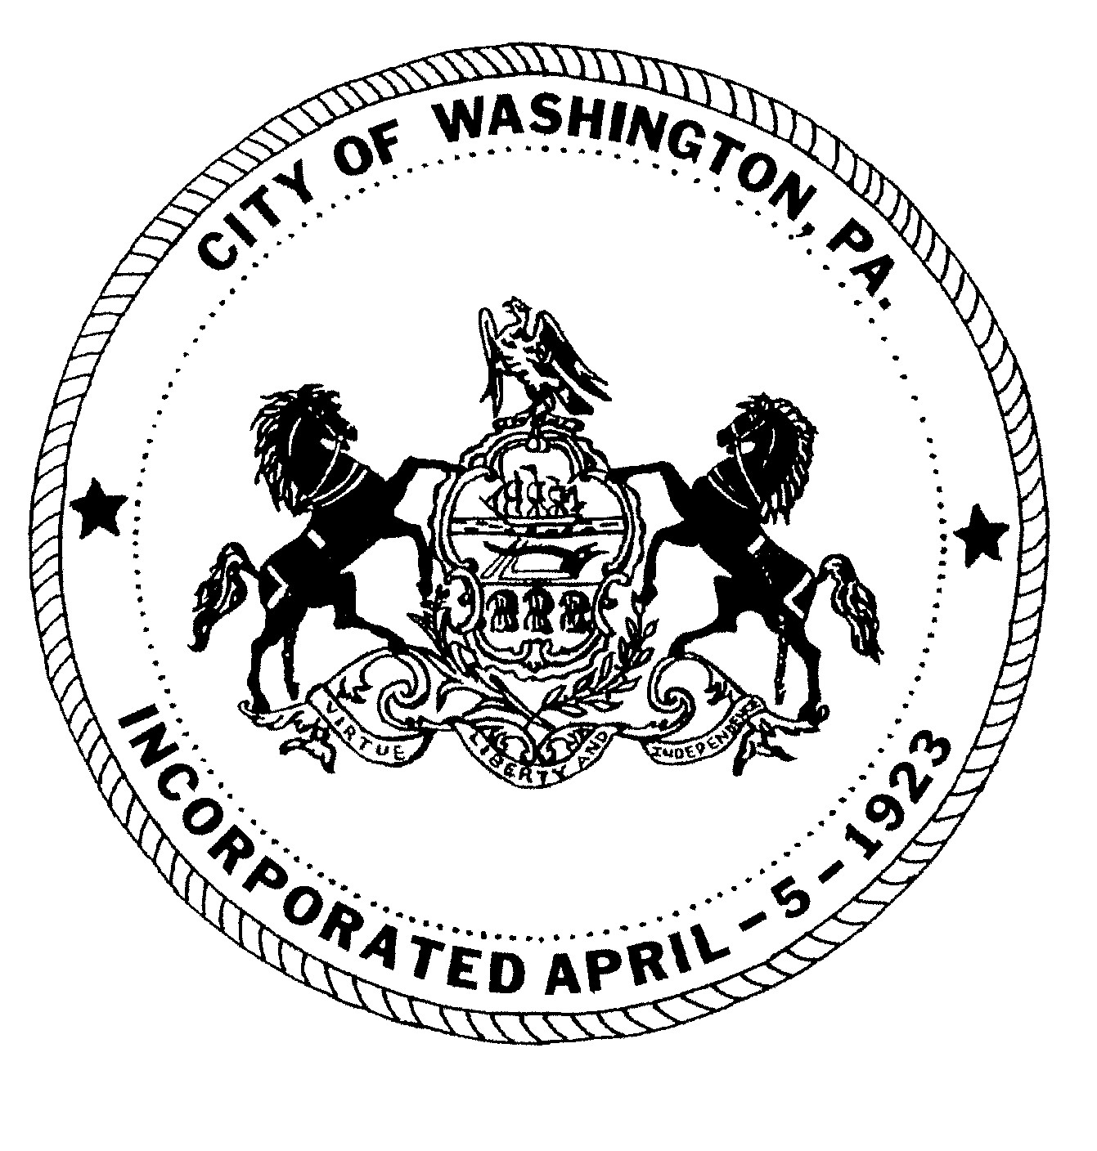
City of Washington
REGULAR MEETING MINUTES
Washington City Council

NOVEMBER 7, 2024 6:00 P.M.
JoJo Burgess, Mayor
City Council
Ken Westcott, Councilman
Joe Pintola, Councilman
Andrew Callan, Councilman
Joseph DeThomas, Councilman

ROLL CALL:
Councilman Joseph DeThomas Present
Councilman Andrew Callan Present
Councilman Joe Pintola Present
Councilman Ken Westcott Present
Mayor JoJo Burgess Present

Solicitor: Jack Cambest Present

MOMENT OF SILENCE:

PLEDGE OF ALLEGIANCE:

PUBLIC PARTICIPATION: Individuals or group representatives who have signed in prior to the meeting will have 5 minutes of microphone time to address Council during the public participation portion of the meeting. We prefer if there is a group, a representative be chosen to speak. Audience comments will not be permitted following the public participation portion of the meeting; therefore, we ask that you please review the agenda for any item(s) you may wish to discuss. We have, in the past, had individuals’ direct comments to the Mayor and Council that were not correct or could not be documented. For that reason, we ask that your information be to the point and factual. Although we may not be able to answer your question at this meeting, we will refer your request or recommendation to the proper department for any necessary action.

PUBLIC COMMENT:
Georgianna Farkas: Complaint about Whitey’s Towing. Stated they had an explosion there and that it’s a matter of time before all of the oil and gas they put in the creek cause serious issues. Said they have tires stacked 4 vehicles high and that it’s an ongoing issue. Complained about the noise coming from there also. Mayor Burgess asked if she called 911 to make noise complaints. She said she has not. Mayor stated that if the noise complaints aren’t filed then nothing could be done about that. Mayor asked Donn Henderson to have Harshman look into it. Councilman DeThomas stated the explosion was contained on October 16, 2024 at 7:30 p.m. and that Code Enforcement is working on this.
Kelly Jones: Talked about putting up Veterans Banners. Asked the City if they would hang the Banners. Mayor Burgess asked her to work with Donn Henderson. He advised her that the City does not have the man power to spend the time it would take to place 50-100 Banners because they have a limited crew. Donn Henderson advised her to put a budget together and get an estimate of what it would cost.

CLOSED TO PUBLIC PARTICIPATION
_________________________________________________________________________________________

CIVIL SERVICE CHAIRMAN TO PRESENT POLICE DEPARTMENT CAPTAIN ELIGIBILITY LIST TO CITY COUNCIL.

Motion made by Councilman Westcott, seconded by Councilman Pintola, and carried unanimously to certify the Police Department’s Captain Eligibility List.
Motion made by Councilman DeThomas, seconded by Councilman Callan, and carried unanimously to approve the Minutes from the October 3, 2024 Regular Council Meeting.
Motion made by Councilman DeThomas, seconded by Councilman Callan, and carried unanimously to approve the Minutes from the October 26, 2024 Special Meeting.
Motion made by Councilman Westcott, seconded by Councilman Pintola, and carried unanimously to approve the following payments (A.-G) in the amount of $66,497.48.
Motion made by Councilman Westcott, seconded by Councilman Pintola, and carried unanimously to approve the following transfer (A.) in the amount of $8,000.00
Motion made by Councilman Westcott, seconded by Councilman Pintola, and carried unanimously to enter into a 5-year agreement with Motorola Solutions for 6 in-car cameras
with license place reading technology.
Motion made by Councilman Westcott, seconded by Councilman Pintola, and carried unanimously to accept the resignation of Sergeant Dan Florian as of 11-5-2024, pay all monies
due and amend the salary Resolution accordingly.
Motion made by Councilman Westcott, seconded by Councilman DeThomas, and carried unanimously to sign the yearly K-9 Program agreement effective 11-7-2024 until 11-7-2025.

RESOLUTIONS
Motion made by Councilman Westcott, seconded by Councilman Pintola, and carried unanimously to approve RESOLUTION 20 of 2024 (BUDGET RESOLUTION)
A RESOLUTION OF THE CITY OF WASHINGTON, WASHINGTON COUNTY, PENNSYLVANIA, APPROPRIATING SPECIFIC SUMS ESTIMATED TO BE REQUIRED FOR THE SPECIFIC PURPOSES FOR THE CITY GOVERNMENT HEREAFTER SET FOR THE YEAR 2025.

Motion made by Councilman Westcott, seconded by Councilman DeThomas, and carried unanimously to approve RESOLUTION 21 of 2024 (SALARY RESOLUTION)

A RESOLUTIONAMENDING ORDINANCE NO. 1356, CHAPTER 1, PART 2,
APPOINTED OFFICERS AND EMPLOYEES FOR THE YEAR 2025.

Motion made by Councilman Westcott, seconded by Councilman Pintola, and carried unanimously to TABLE the motion to approve RESOLUTION 22 of 2024
Whereas the City of Washington Council, pursuant to the City Code Chapter 2 Section 294-4, may upon proper meeting and taking all necessary steps incident thereto required to effectuate the adoption and passage of action to set fees for collection and disposal of solid waste, shall designate the fees for collection of solid waste and designated recyclables, and;
Whereas the contracted fees for the City for the year 2025 have been reviewed and
an amount established for collections now,
Therefore, be it resolved that the fees and deadlines are as follows;
-Annual fee $300 due by June 1.
-Late fee of $50 added if paid between June 2 and October 31.
- November 1, 2025 -December 31, 2025 $350 plus fines and penalties as established by the tax collection agency.
ORDINANCES
Motion made by Councilman Westcott, seconded by Councilman Pintola, and carried unanimously to approve ORDINANCE 1977 BILL NO. 4 of 2024
AN ORDINANCE AMENDING ORDINANCE NO 1356, CHAPTER 24, PART 5, LEVYING A TAX AND FIXING A TAX RATE FOR ALL CITY PURPOSES ON THE VALUATION OF SUCH PROPERTY AS HAS BEEN OR MIGHT HEREAFTER BE ASSESSED AND SUBJECT TO TAXATION FOR THE YEAR 2025.

DISCUSSION:
Councilman Joseph DeThomas –Thanked the Civil Service and thanked Dan Florian for his service. Thanked Deanna Martin for her work on Dark in the Park.

Councilman Andrew Callan- Shared that the 7th Ward Playground has been paved and that the basketball hoops will be placed back up at the playground in the spring.

Councilman Joe Pintola – Shared that all paving by the City and that the City contracted out is complete for 2024.

Councilman Ken Westcott – Stated that there will be a tax increase for 2025. Currently it is looking to be a 1.5 mil increase. The last increase was in 2019.
Mayor JoJo Burgess- Asked for a Motion to be made on the Police Contract.
Motion made by Councilman Westcott, seconded by Councilman Pintola, and carried unanimously to approve the City Police Department contract retroactive to January 1, 2024.

ROLL CALL:
Councilman DeThomas YES
Councilman Callan YES
Councilman Pintola YES
Councilman Westcott YES
Mayor Burgess YES

Solicitor Jack Cambest – No Comment

- City offices closed Monday, November 11, 2024 in observance of Veteran’s Day.
- City offices closed on November 28th & November 29th in observance of Thanksgiving.
- LEAF PICKUP IS NOVEMBER 1, 2024 -NOVEMBER 30, 2024 (Mondays, Wednesdays, & FRIDAYS ~excluding HOLIDAYS.
- Light Up at Lemoyne Friday, November 29, 2024 from 4 P.M. until 7:00 P.M. at Strawberry Alley.
- Small Business Saturday is November 30, 2024.
- Christmas Parade, Saturday, November 30, 2024.
- Ugly Sweater Pop Up Bar at Grand Pavilion Friday December 6, 2024.
- Family Christmas Party (Small Children) at Grand Pavilion Saturday, December 7, 2024
- Winter Social for Teenagers at Grand Pavilion Saturday, December 14, 2024

Motion made by Councilman Westcott, seconded by Councilman Pintola, and carried unanimously to adjourn the meeting.

