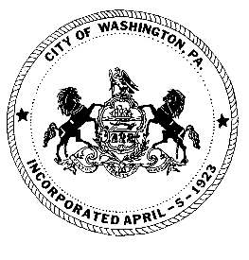
City of Washington

SPECIAL MEETING MINUTES
Washington City Council

JANUARY 22, 2025 5:15 P.M.

City Council
Ken Westcott, Councilman
Joe Pintola, Councilman
Andrew Callan, Councilman
Joseph DeThomas, Councilman

JoJo Burgess, Mayor

ROLL CALL:
Councilman Joseph DeThomas PRESENT
Councilman Andrew Callan PRESENT
Councilman Joe Pintola PRESENT
Councilman Ken Westcott PRESENT
Mayor JoJo Burgess PRESENT

Solicitor: Jack Cambest ABSENT

PUBLIC PARTICIPATION: Individuals or group representatives who have signed in prior to the meeting, will have 5 minutes of microphone time to address Council during the public participation portion of the meeting. We prefer if there is a group, a representative be chosen to speak. Audience comments will not be permitted following the public participation portion of the meeting; therefore, we ask that you please review the agenda for any item(s) you may wish to discuss. We have, in the past, had individuals’ direct comments to Mayor and Council that were not correct or could not be documented. For that reason, we ask that your information be to the point and factual. Although we may not be able to answer your question at this meeting, we will refer your request or recommendation to the proper department for any necessary action.

PUBLIC COMMENT: NO ONE SIGNED UP TO SPEAK
Public Comment Closed.
Motion made by Councilman Westcott, seconded by Councilman Pintola, and carried unanimously to approve the following payments (A-B.) in the amount of $4,867.97.
Motion made by Councilman Westcott, seconded by Councilman DeThomas, and carried unanimously to approve the following refund (A) in the amount of $225.00
Motion made by Councilman Pintola, seconded by Councilman Westcott, and carried unanimously to approve placing Police Officer (JF) on Heart and Lung effective January 13,
2025.
Motion made by Councilman DeThomas, seconded by Councilman Westcott, and carried unanimously to approve $1,500.00 expense training advance for attendance at the Harrisburg Fire Academy to Ben Schweiger. CHARGE: 01.33/411-266
Motion made by Councilman DeThomas, seconded by Councilman Callan, and carried unanimously to approve $1,500.00 expense training advance for attendance at the Harrisburg Fire Academy to Stefan Richer. CHARGE: 01.33/411-266

ORDINANCES
Motion made by Councilman Westcott, seconded by Councilman Pintola, and carried unanimously to approve the FINAL READING of ORDINANCE 1978 BILL NO. 1 OF 2025
AN ORDINANCE OF THE COUNCIL OF THE CITY OF WASHINGTON, WASHINGTON COUNTY, PENNSYLVANIA, AMENDING PART II: GENERAL LEGISLATION, ARTICLE I – MERCANTILE LICENSE TAX, SECTIONS 325-1 DEFINITIONS, 325-3 AND 325-11(C)(4)(A) PROVIDING FEES BE SET BY RESOLUTION; SECTION 325-8 TREASURER AUTHORITY; SECTION 325-9 SUIT ON COLLECTION; AND SECTION 325-10 (SETTING VIOLATIONS AND PENALTIES.)
Motion made by Councilman Westcott, seconded by Councilman Pintola, and carried unanimously to approve the FINAL READING of ORDINANCE 1979 BILL NO 2 OF 2025
AN ORDINANCE OF THE COUNCIL OF THE CITY OF WASHINGTON, WASHINGTON COUNTY, PENNSYLVANIA, AMENDING PART II: GENERAL LEGISLATION, ARTICLE III – BUSINESS PRIVILEGE TAX, SECTIONS 325-31 (DEFINITIONS), 325-34 (REGISTRATION), 325-37 (TREASURER AUTHORITY), 325-38 (SUIT ON COLLECTIONS) AND 325-39 (SETTING VIOLATIONS AND PENALTIES.)

DISCUSSION:

Councilman Joseph DeThomas – Thanked Council for approving to send the new firemen to the Fire Academy.

Councilman Andrew Callan- No comment

Councilman Joe Pintola – Stated that the Street Department has been busy.

Councilman Ken Westcott – No Comment
Mayor JoJo Burgess- No Comment

The next Agenda meeting will be held on Monday, February 3, 2025 at 6:00 P.M. and the next Regular Council Meeting will be held on Thursday, February 6, 2025 at 6:00 P.M.

Motion made by Councilman Westcott, seconded by Councilman DeThomas, and carried unanimously to adjourn.

CITY OF WASHINGTON

BY:
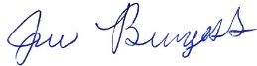
_______________________
JoJo Burgess, Mayor

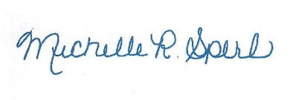
ATTEST:

_________________________ Michelle R. Sperl, City Clerk

